Praying with Purpose: Lord, teach us to pray…

You may like to use this resource for personal reflection or a group time of encouragement to prepare for supporting an initiative in prayer
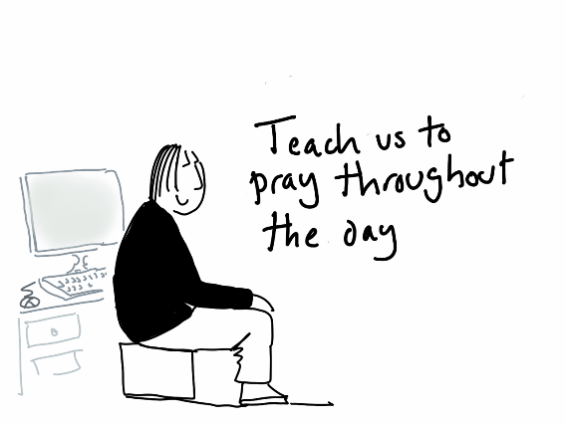

Teach us to pray throughout the day

Loving Lord,
as the disciples, so we ask,
show us how to pray.

In the early morning, while it was still dark, Jesus got up, left the house,
and went away to a secluded place, and was praying there.
Jesus went up on the mountain by himself to pray;
and when it was evening, he was there alone.
Mark 1:35; Matthew 14:23 (AMP)

Lord Jesus,
you were faithful in prayer:
you took time aside from the crowds
to share with your heavenly Father.

Help us to mirror your example:
to take time throughout the day
to share with our heavenly Father.

From daybreak to sunset,
however the day unfolds ,
may time with our heavenly Father
be our desire and delight.

Loving Lord,
our perfect example,
show us how to pray. Amen

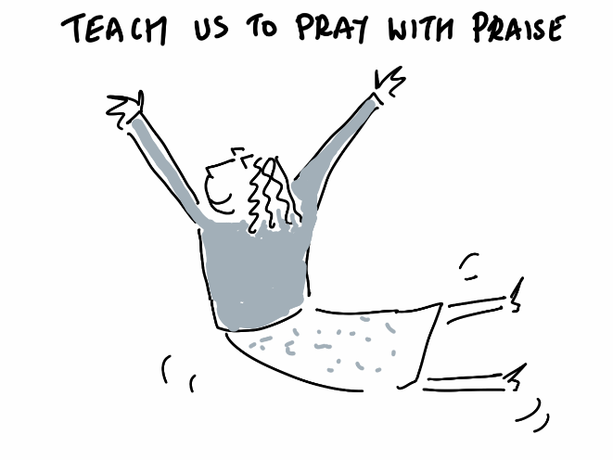

Teach us to pray with praise

Loving Lord,
as the disciples, so we ask,
show us how to pray.

Jesus, full of joy through the Holy Spirit, said, ‘I praise you, Father, Lord of heaven and earth, because you have hidden these things from the wise and learned, and revealed them to little children. Yes, Father, for this is what you were pleased to do. Luke 10:21

For the joy of your presence
changing and renewing us
day by day,
we offer you our praise.
For the blessing you bring us,
the outpouring of your love
day by day,
we offer you our praise.
For the Word that endures,
teaches and challenges,
generation to generation,
we offer you our praise.
© John Birch

Loving Lord,
our perfect example,
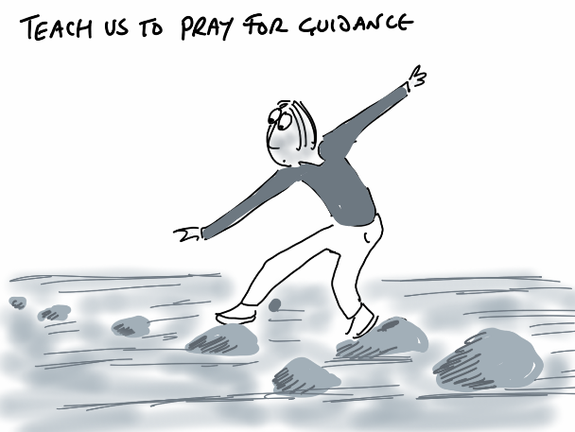
show us how to pray. Amen

Teach us to pray for guidance

Loving Lord,
as the disciples, so we ask,
show us how to pray.

One of those days Jesus went out to a mountainside to pray,
and spent the night praying to God. When morning came,
he called his disciples to him and chose twelve of them,
whom he also designated apostles.
Luke 6:12-14

God of perfect wisdom,
we pray for your guidance
at times when we struggle to see the way
through a maze of life’s options,
conflicting opinions, wavering loyalties.

May we always seek your loving insight
when decisions lie before us;
May prayer be ever our compass
to direct us along the right path.

Loving Lord,
our perfect example,
show us how to pray. Amen

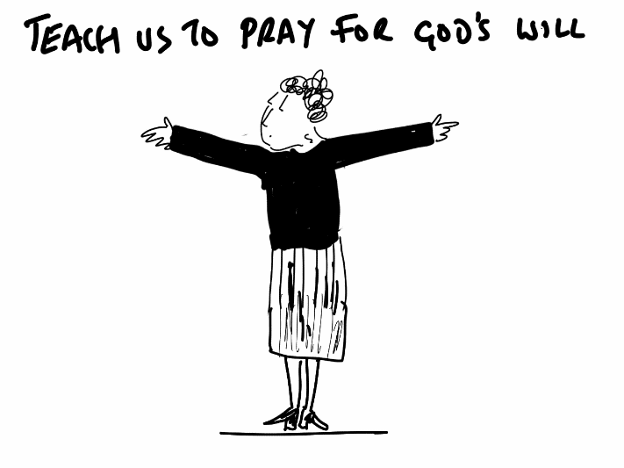

Teach us to pray for God’s will

Loving Lord,
as the disciples, so we ask,
show us how to pray.

Jesus bowed with his face to the ground, praying,
‘My Father! If it is possible, let this cup of suffering
be taken away from me. Yet I want your will to be done, not mine’ Matthew 26:39 (NLT)

When we face life’s trials and challenges
Our Father, we pray for your will to be done.

In the petty irritations which pepper our days
Our Father, we pray for patience and grace.

At times when we are overwhelmed and weak
Our Father, we pray for courage and strength.

In the full-scale crises which cause us such pain
Our Father, we pray for your will to be done.

Loving Lord,
our perfect example,
show us how to pray. Amen

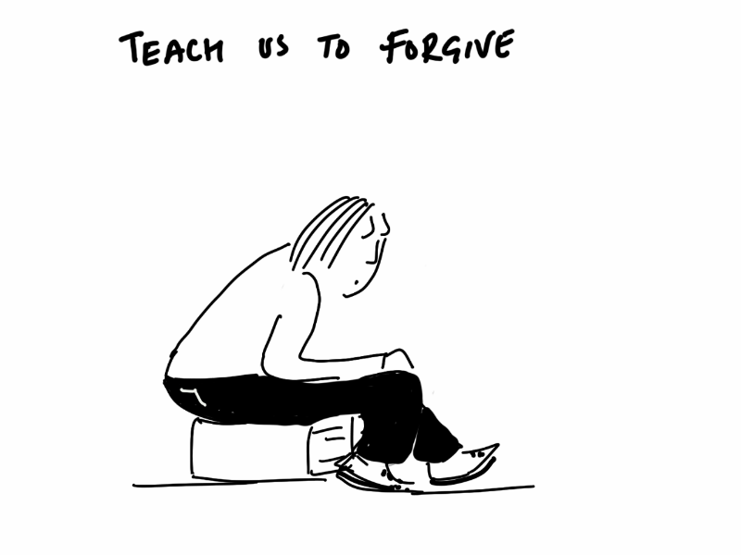

Teach us to pray to forgive

Loving Lord,
as the disciples, so we ask,
show us how to pray.

Jesus said, “Father, forgive them,
for they do not know what they are doing.”
Luke 23:34

How can I forgive
when I have suffered such hurt?
Why should I forgive
when no mercy is deserved?

Loving Saviour,
your words of absolute forgiveness
stop me in my track of condemnation
and drive me to prayer.

The glory of your compassion
overshadows my case for justice
and drives me to prayer.

Loving Saviour
forgive me when I deny others
that which you freely bestow.
How can I not forgive
when I have received such mercy?

Loving Lord,
our perfect example,
show us how to pray. Amen

Lord, teach us to pray

One day Jesus was praying in a certain place.
When he finished, one of his disciples said to him,
“Lord, teach us to pray.”
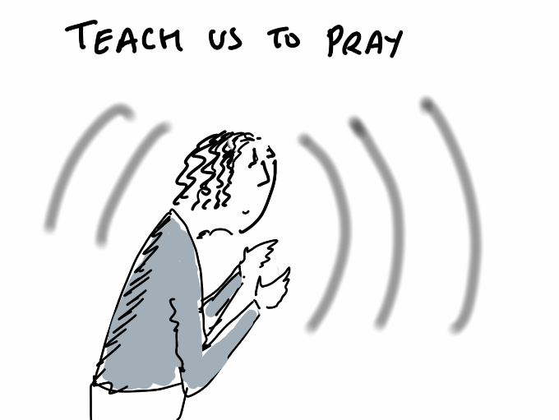
Luke 11:1

Lord God,
like the disciples we ask,
teach us how to pray.

Teach us the secret of prayer –
when to speak and when to keep silent,
when to accept and when to go on seeking,
when to persevere and when to let go,
teach us how to pray.

Teach us the power of prayer –
its ability to challenge,
to encourage, to transform all life,
teach us how to pray.

Teach us the joy of prayer -
to express our worship,
discover your will,
and hear your voice.
In the name of Christ. Amen
Nick Fawcett (adapted)

Blessing

All glory be to Christ, who is seated at the right hand of the Father,
and ever lives to intercede for us. Amen

